Product Requirements Document- FDelivery

# Objective

|  |  |
| --- | --- |
| Vision | increasing income for businesses, providing job options for couriers and making an easier life of purchasing for customers |
| Goals | release an app and watch it become popular |
| Initiatives | Give small businesses a lightweight and cheap alternative to conventional delivery methods in the market. |
| Persona(s) | small businesses ,couriers |

# Release

customer = store owner

courier = שליח

Destination = צרכן קצה

1. login - customer / Courier - Login to system
2. Customer set a delivery order to be made to the pool - place an order
3. couriers in the area can see the pool and choose a delivery to make - show pool of deliveries
4. customer sees a courier has been assigned to the delivery order - choose delivery to make
5. courier gets to the store and delivery has started - package sent from the store &courier deliver the goods and delivery is done - package arrived to destination
6. manage deliveries - see delivery history(courier, store owner)
7. pay/ get paid

|  |  |
| --- | --- |
| Release | FDelivery |
| Date | 28.6.21 |
| Initiative | Simplified the act of delivering goods from stores to customers |
| Milestones | Upload the app to the app store |
| Features | Business + courier 1)login  Business 2)place an order  courier 3)watch available deliveries  courier 4)choose delivery to make  Business 5)watch delivery status  Business + courier 6)pay/get paid  Business + courier 7)see delivery history |
| Dependencies | working in collaboration and following the timeline we set for the release. |

# Features -

|  |  |
| --- | --- |
| Feature | Login |
| Description | user (i.e store owner or courier) login with credentials in order to use FDelivery app. |
| Purpose | identify returning user |
| User problem | repeatable registration |
| User value | avoid repeatable registration, see previous activities, watch content according to saved preferences. |
| Assumptions | login should be quick as possible |
| Acceptance criteria | valid credentials of already registered users. |

|  |  |
| --- | --- |
| Feature | place an order |
| Description | the business owner will first record limited shipping details: destination address, type of cargo and proposed payment. (After confirming the shipment, the courier will be exposed to the rest of the details) |
| Purpose | That a courier will choose to make the shipment |
| User problem | It is possible that one of the delivery specifications will not be liked by the courier and the delivery will not be selected quickly |
| User value | Due to the free market of couriers, there is an option to reduce the payment offered for delivery and thus save money |
| Assumptions | Technically the method of placing an order to couriers can be difficult.  Long-range shipments will probably not be answered |
| Acceptance criteria | Accurate delivery details and compatible with the proposed payment |

|  |  |
| --- | --- |
| Feature | Watch available deliveries |
| Description | After logging in, the courier can watch a list of all waiting deliveries. |
| Purpose | Let the courier choose the delivery he wants, also provide job opportunities to couriers. |
| User problem | no interest in any of the deliveries |
| User value | choose between deliveries, earn money from deliveries |
| Assumptions | courier accepts the delivery committing to some base requirements |
| Not doing | Anything that is out of scope for this feature |
| Acceptance criteria | only detailed deliveries will be displayed |

|  |  |
| --- | --- |
| Feature | choose delivery to make |
| Description | The courier has the option to see orders and confirm those he undertakes to make |
| Purpose | The courier will make deliveries that suit his personal time |
| User problem | He may find himself compromising and flexible to make deliveries (in terms of delivery area convenience and in terms of payment) |
| User value | Due to the lack of existing jobs in the market the courier can make a lot of money with the help of the app |
| Assumptions | Gaining a large courier crowd may take some time |
| Acceptance criteria | A large amount of couriers is needed |

|  |  |
| --- | --- |
| Feature | watch delivery status |
| Description | The business owner will see if his shipments have been taken by courier and whether it arrived at the destination or waiting. |
| Purpose | The business owner Will be able to be constantly monitored for his shipments and know if and when his shipment has arrived at its destination successfully and If there are delays. |
| User problem | Incorrect status report |
| User value | Constant monitoring. Alert to customer in case of delay or problem |
| Assumptions | Updating the status depends on the reliability and accuracy of the courier |
| Acceptance criteria | Correct and real-time update |

|  |  |
| --- | --- |
| Feature | pay/get paid |
| Description | A business owner will be able to pay for the order made by the courier from his store in the app.  And every courier will be able get the payment |
| Purpose | Increase security of payment for the courier and make it easy for the shop owner to pay for his deliveries |
| User problem | Shop owner doesn't pay or pay less the agreed |
| User value | Make it easy and accessible and increase security for courier |
| Assumptions | We will be able to manage this transaction which are heavily regulated |
| Acceptance criteria | only payment for real deliveries |

|  |  |
| --- | --- |
| Feature | see delivery history |
| Description | Every business owner will be able to see all the orders ever made from his store in the app.  And every courier will be able to see all the shipments he has made |
| Purpose | Arranged monitoring of business activity for a variety of needs like  In case of a complaint make sure it is justified and see who made the shipment and when. |
| User problem | Incorrect data entry |
| User value | Tracking expenses and income. |
| Assumptions | All important details should be included and understood |
| Acceptance criteria | nothing. Each shipment will enter the list with maximum details |

# User flow and design-

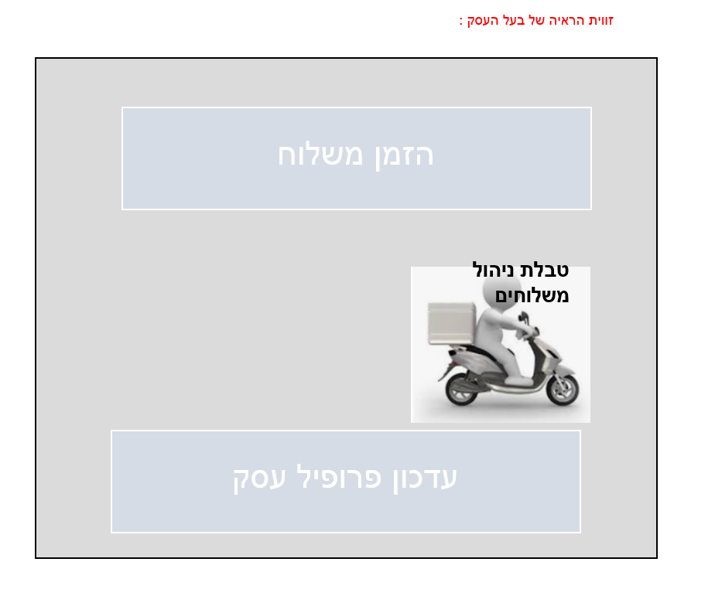

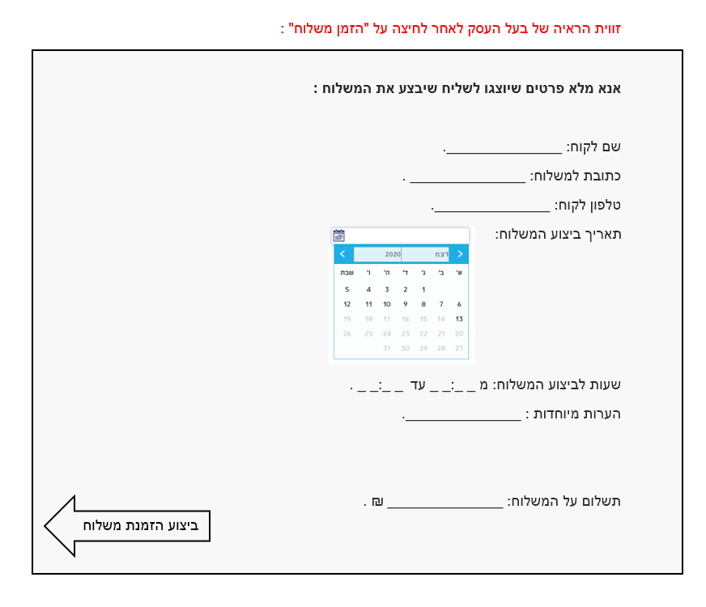

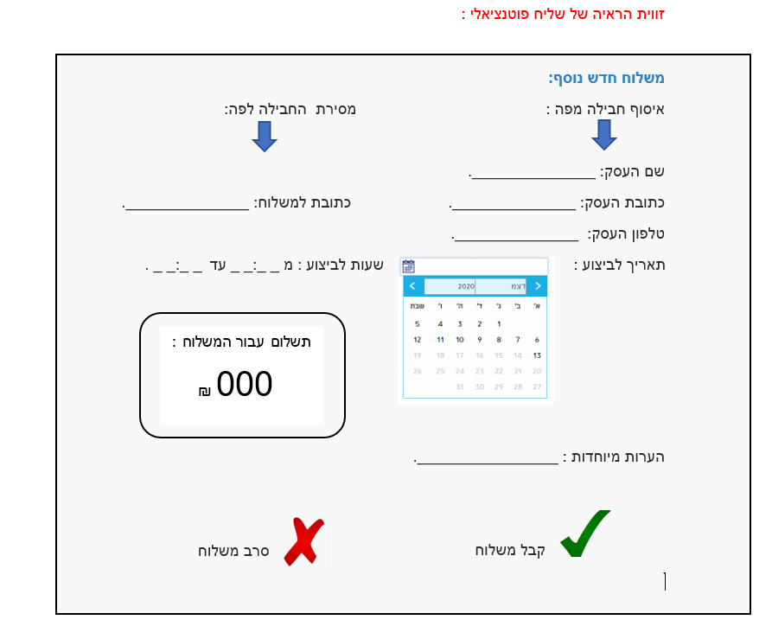

# Analytics

We believe login will achieve better control and understanding over users and their app usages and will increase the feeling of security among the users.

|  |  |  |  |
| --- | --- | --- | --- |
| Key performance indicator | Baseline | Target | Timeframe |
| Number of users | 0 | 100 | 1 month |

We believe placing an order is a key part in the app and will achieve a higher control for business and a side hustle for courier.

|  |  |  |  |
| --- | --- | --- | --- |
| Key performance indicator | Baseline | Target | Timeframe |
| Number of deliveries placed by business | 0 | 250 | 2 month |

We believe watching available deliveries make will achieve higher control and better satisfaction for courier making deliveries

|  |  |  |  |
| --- | --- | --- | --- |
| Key performance indicator | Baseline | Target | Timeframe |
| Number courier in system | 0 | 50 | 1 month |

We believe choosing delivery to make will achieve a way to ensure the delivery is made appropriately and most efficiently.

|  |  |  |  |
| --- | --- | --- | --- |
| Key performance indicator | Baseline | Target | Timeframe |
| average time for a delivery to be made | -- | 20m | -- |

We believe watching delivery status will achieve a higher control for business for their deliveries and higher satisfaction.

|  |  |  |  |
| --- | --- | --- | --- |
| Key performance indicator | Baseline | Target | Timeframe |
| Providing delivery status that matches reality | 0 | Any delivery | All the time |

We believe pay/getting paid will achieve a security feeling and accessibility for our users.

|  |  |  |  |
| --- | --- | --- | --- |
| Key performance indicator | Baseline | Target | Timeframe |
| Number of payment made | 0 | 100 | 1 Month |

We believe seeing delivery history will achieve a better understanding of the deliveries and expenses for the store owner.

|  |  |  |  |
| --- | --- | --- | --- |
| Key performance indicator | Baseline | Target | Timeframe |
| by number of times The business owner enters the table to find out his delivery history | 0 | 2 | per a day |

# Future work

|  |  |  |  |
| --- | --- | --- | --- |
| Future features | Purpose | Priority | Timeframe |
| Add a review to the store  and courier. | Make it easier for other users to decide what level of service each user provides | medium | According to users requirements |
| Add Users Quick contact to give us feedback and ways to improve the app. | For improving the app and adding features according to the needs of the customers. | medium | According to users requirements |
| GPS tracking of the shipment and updating its location in real time. | Know immediately when there is a problem with the shipment and provide peace of mind to the business owner who knows that the shipment is correct and is on his way to the destination. | medium | antill 6 months after the app was released to the store. |
| Allowing end customers to enter a residential address in the app and it will show him all the stores in his area (within a certain range) | Convenience for him who knew which stores were nearby and linked to FDelivery  In addition, it contributes to the advertising of the businesses linked to FDelivery | low | About 6 months after the app was released to the store. |
| Allowing end customers to place an order from the app (involves adding a list of stores to the app and listing the products that can be ordered from each store) | Allowing end customers to place an order from the app (involves adding a list of stores to the app and listing the products that can be ordered from each store) | low | Once we have verified that the app is working properly and the users are satisfied with the existing one we will move on to this step. |